


PERTANDINGAN WORLDSKILLS MALAYSIA KATEGORI BELIA (WSMB) TAHUN 2025

IT SOFTWARE SOLUTION FOR BUSINESS

SOALAN PRAKTIKAL - PENGATURCARAAN

PERINGKAT PRA-KELAYAKAN

MASA : 2 @ 3 JAM

NAMA: _______________________________________

No. KP: _______________________________________

JABATAN PEMBANGUNAN KEMAHIRAN
KEMENTERIAN SUMBER MANUSIA

Description of Project and Tasks - Programming

This project consists of three questions. The table below describe the topics that are covered for each question. You are allowed to write the program using C, C++ or Java programming language.

Question | Topic | Duration | Marks
1 - open | One Dimensional Array | 2 hours | 10
2 - close | Programming Logic (function, conditional and iteration) | 2 hours | 25
3 - close | Applied Problem Solving | 2 hours | 25
Total |  |  | 60

Prior to the start of the competition, participants will be given 15 minutes to understand the question and the marking scheme. Participants will be given the opportunity to ask the judges any questions that arise or the marking scheme.

Note: If you are in doubt about any other tools or programming language you wish to use, check with the judges before you start.

QUESTION 1
Write a program with at least five (5) functions or methods inclusive of function main. There must be at least one function (method) using the concept of pass-by-value and one function using the concept of pass-by-reference (if applicable). The program must enable user to enter marks for each subject into an array of double data type. The program should calculate and display the total mark, the average mark and medal based on criteria below.
Marks | Grade Point
80 and above | 4
60 and less than 80 | 3
40 and less than 60 | 2
0 and less than 40 | 1

Average Grade Point  (total grade point/no of subject) | Medal
3.50 and above | Platinum
3.00 and less than 3.50 | Gold
2.00 and less than 3.00 | Silver
0 and less than 2.00 | Bronze

Input Validation : Do not accept negative numbers for marks.

Your marks will be given based on the criteria:

- Input and output of marks as shown below. (2 marks)

Example 1
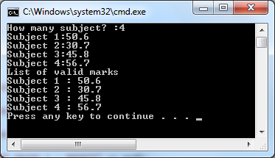

- Input and output of marks with TOTAL GRADE POINT and AVERAGE GRADE POINT as shown below. (3 marks)

Example
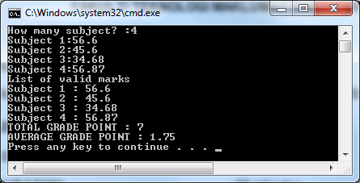

- Input and output of marks with input validation for negative number. In addition, your program is able to calculate and display TOTAL GRADE POINT and AVERAGE GRADE POINT as shown below. (1 mark)

Example
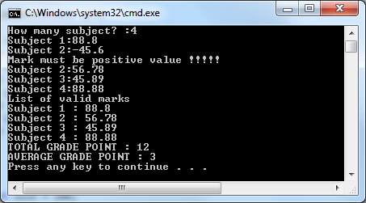

- Input and output of marks with input validation for negative number. In addition, your program is able to calculate and display TOTAL GRADE POINT and AVERAGE GRADE POINT. On top of that, your program is able to determine medal which depend on the average grade point as shown below. (1 mark)

Example
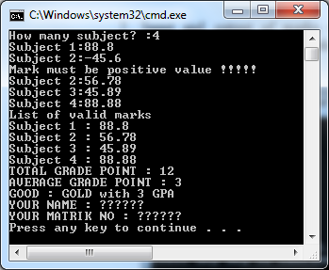

Another useful example to test your program.

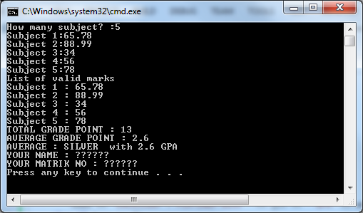

Marking Scheme for Question 1:

Item | Marks | Marks Given
Item 1 – need to check the number of subjects | 2
Item 2 – determine grade point, calculate total and average grade point | 3  (1 marks for each task)
Item 3 – input validation | 1  (using looping or recursive function)
Item 4 – determine medal | 1
QUALITY ASPECT OF A PROGRAM
Useful comments – at least 5 useful comments in a program | 1
Variable name for each function must not be the same and satisfy the minimum number (5) of functions or methods | 1
Variable name must follow some naming convention and reflect the purpose of it. | 1
Total Marks | 10

